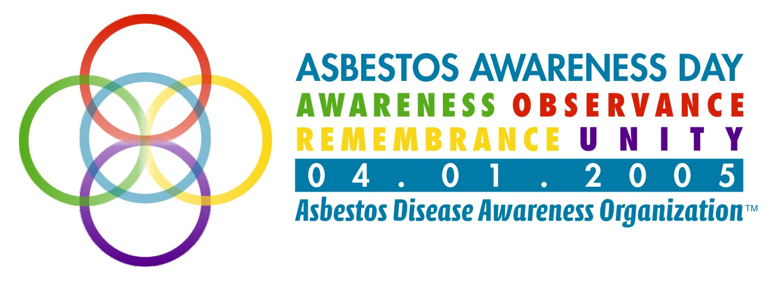

For Immediate Release:
Tuesday, February 08, 2005

U.S. Senator Harry Reid Re-Introduces Resolution Calling for

National Asbestos Awareness Day

Legislation Promotes Increased Awareness of the Dangers of Asbestos

Washington, DC … Tuesday, February 08, 2005 --- The Asbestos Disease Awareness Organization (ADAO), an organization dedicated to serving as the voice of asbestos victims, today applauds Senator Harry Reid (D-NV) for re-introducing a resolution designating April 1st as “National Asbestos Awareness Day.” This resolution, proposed by the Asbestos Disease Awareness Organization, will raise public awareness about the dangers of asbestos exposure and asbestos related diseases.

“ADAO praises Senator Reid for re-introducing the Senate Asbestos Awareness Day Resolution,” said Jordan Zevon, ADAO National Spokesperson. “Senator Reid is taking an important stance on behalf of current and future asbestos victims and we hope that his Senate colleagues will follow suit and support this important resolution.”

“Senator Reid’s Resolution is the first proposed bill that takes into account the voice of the asbestos victims,” said Linda Reinstein, Co-Founder & Executive Director, Asbestos Disease Awareness Organization. “This Resolution will help ADAO create a national movement that embraces awareness, prevention, remembrance and unity – so that we can ultimately win the fight against asbestos disease with the most powerful weapon of all – hope.”

# # #

About Asbestos Disease Awareness Organization
Asbestos Disease Awareness Organization (ADAO) was founded by asbestos victims and their families. ADAO seeks to give asbestos victims and concerned citizens a united voice to help ensure that their rights are fairly represented and protected, while raising public awareness about the dangers of asbestos exposure and often deadly asbestos related diseases. ADAO is an independent organization funded through voluntary contributions and staffed by volunteers. For more information visit www.asbestosdiseaseawareness.org

Media Contact:
Douglas Larkin
Communications Director
Asbestos Disease Awareness Organization (ADAO)
Phone: (703) 250-3590 x1245
Cell: (202) 391-1546
doug@asbestosdiseaseawareness.org

