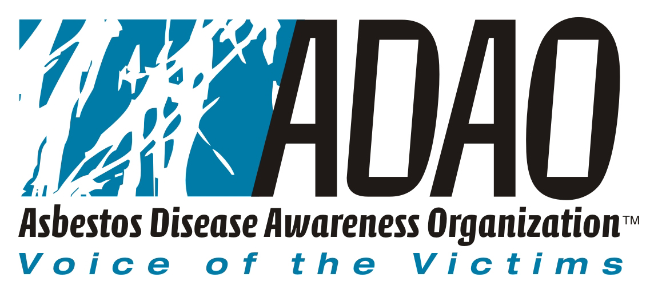

For Immediate Release:
Thursday, May 26, 2005

Asbestos Disease Awareness Organization Calls Asbestos Trust Fund Legislation “Corporate Bailout”

Leading Asbestos Victims Group Expresses Extreme Disappointment over Senate Judiciary Passage of S. 852

Washington, DC … May 26, 2005 --- The Asbestos Disease Awareness Organization (ADAO), an organization dedicated to serving as the voice of asbestos victims, today announced its extreme disappointment regarding the passage S. 852, the asbestos trust fund bill sponsored by Senator Arlen Specter (R-PA).

“We are sorely disappointed that S. 852 has been voted out of the Judiciary Committee. It is clear that the victims and their families were not considered stakeholders,” according to ADAO President Alan Reinstein. “This legislation does not adequately protect the rights of present and future victims and we hope the Senate does the right thing by voting ‘no’ on this corporate bailout bill.”

ADAO, which represents an thousands of asbestos victims that is growing daily, has continually voiced opposition to the bill, which does not adequately represent the rights of those affected by asbestos. Specifically:

- ADAO’s Science Advisory Board strongly objects to the outdated and incorrect medical criteria in S. 852 describing the symptoms, diagnosis and severity of asbestos related diseases. ADAO recommends that any piece of legislation should follow the established American Thoracic Society guidelines to diagnose and treat asbestos related diseases.
- The bill contains inordinate compensation delays and ineligibility for the victims.
- The bill has inadequate funding for not only research, but education, prevention and outreach.
- The trust fund faces insolvency long before all present and future victims can access it.

ADAO Co-founder and Executive Director Linda Reinstein explained in a statement to the Senate Judiciary Committee earlier this year that: “Asbestos diseases can take twice as long to appear as the fund is designed to last. That leaves millions of Americans exposed to asbestos with a fund that is destined to become insolvent…Once again, sick and dying victims will be at the mercy of bureaucracy and receive more aggravation than compensation…We are not principally opposed to a trust fund. But it makes good business sense to design a fair and balanced fund that provides speedy compensation and adequate funding for research, education and outreach. Give the victims the right to choose the fund or a trial. Citizens need to make certain before they give up their right to a trial, that a national trust fund has sufficient funding for the future.”

# # #

About Asbestos Disease Awareness Organization
Asbestos Disease Awareness Organization (ADAO) was founded by asbestos victims and their families. ADAO seeks to give asbestos victims and concerned citizens a united voice to help ensure that their rights are fairly represented and protected, while raising public awareness about the dangers of asbestos exposure and often deadly asbestos related diseases. ADAO is an independent organization funded through voluntary contributions and staffed by volunteers. For more information visit www.asbestosdiseaseawareness.org

Media Contact:
Doug Larkin
Director of Communications
Asbestos Disease Awareness Organization (ADAO)
Phone: (703) 250-3590 x1245
Cell: (202) 391-1546
doug@asbestosdiseaseawareness.org

