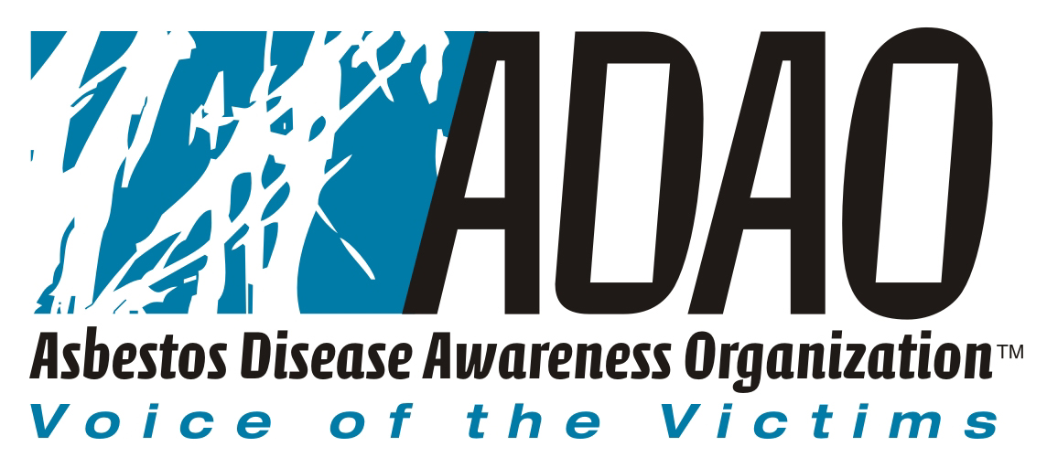

For Immediate Release:
June 27, 2005

Victim’s Organizations Form Asbestos Victims Coalition in Opposition to Asbestos Trust Fund Legislation

Organizations Opposed to Specter-Leahy Trust Fund Legislation; Coalition to Highlight Realities of National Asbestos Trust Fund on Victims and Victim’s Families

Washington, DC … June 27, 2005 --- The Asbestos Disease Awareness Organization (ADAO) today announced the formation of the Asbestos Victims Coalition, comprised of consumer groups, victims organizations and specialists working together to ensure that the voice of asbestos victims is fairly represented. Specifically, the Coalition is working to raise awareness about the inequities in the asbestos trust fund legislation proposed by Senators Arlen Specter (R-PA) and Patrick Leahy (D-VT).

The Coalition, with broad based support from across the globe, includes:
- Asbestos Disease Awareness Organization
- Asbestos Victims Organization
- Ban Asbestos and Eliminate Mesothelioma
- Committee to Protect Victims of Mesothelioma
- David Egilman MD, MPH, Brown University
- Environmental Working Group
- International Ban Asbestos Secretariat
- Mesothelioma Support Organization
- New York Committee for Occupational Safety and Health (NYCOSH)
- Palmer Electric Company
- Public Citizen
- Sciencecorps.org
- Society for The Advancement of Occupational and Environmental Health (SAOEH)
- Terry Trent Biologist/Asbestos Activist
- U.S. Action
- White Lung Asbestos Information Center
- White Lung Association
- 9/11 Environmental Action
- Asbestos Diseases Advisory Services of Australia
- Asbestos Diseases Society of Australia

This growing list of coalition members is available online and updated daily to accommodate additional organizations. ADAO invites and encourages other interested parties to come forward to join the opposition by visiting:
http://www.asbestosdiseaseawareness.org/eLibrary/coalition-05.doc

The coalition’s opposition campaign includes asbestos victim “fly-ins” to meet and educate the entire U.S. Senate. The priority theme will be to illustrate how victims will be adversely affected by the proposed bill.

“There is strength in numbers and while the number of asbestos victims is unfortunately growing beyond anyone’s control – so, too, are the number of voices coming forward to speak out for their rights,” stated Linda Reinstein, Co-founder and Executive Director, ADAO. “We are extremely pleased to have the opportunity to unite the key stakeholders through such a varied and committed group of organizations and individuals represented by the Asbestos Victims Coalition and look forward to the substantial progress we can make together.”

“The asbestos debate has unfortunately become one about corporate bailouts instead of asbestos realities,” stated Douglas Larkin, Co-founder and Communications Director, “In the recent Senate floor debate, for example, concerns were raised that companies may go bankrupt as a result of asbestos litigation. The bigger issue is whether or not asbestos victims and their families will get the support they need and deserve, in a timeframe that makes realistic sense, given the extreme realities of asbestos disease.”

# # #

About Asbestos Disease Awareness Organization
Asbestos Disease Awareness Organization (ADAO) was founded by asbestos victims and their families. ADAO seeks to give asbestos victims and concerned citizens a united voice to help ensure that their rights are fairly represented and protected, while raising public awareness about the dangers of asbestos exposure and often deadly asbestos related diseases. ADAO is an independent organization funded through voluntary contributions and staffed by volunteers. For more information visit www.asbestosdiseaseawareness.org

Media Contact:
Doug Larkin
Co-Founder & Communications Director
Asbestos Disease Awareness Organization (ADAO)
(703) 250-3590 Ext. 1245
(202) 391-1546 Cell

